IT24100348

1)

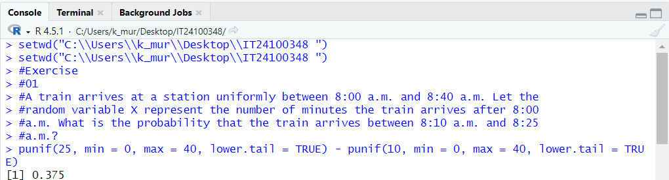

2)

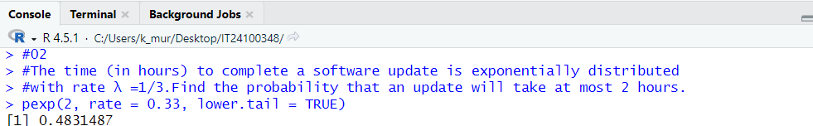

3)

